Task on vpc-2
- Create one VPC, with 1 public subnet and 1 private subnet.
Go to vpc services create vpcadd name add IPV4 CIDR blockcreate vpc.
Now, vpc is created.
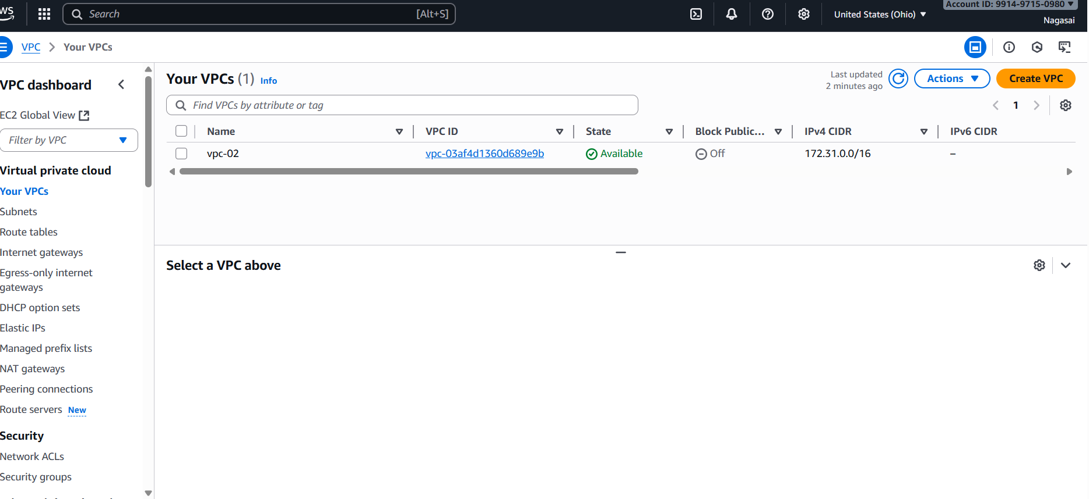
And also add one public subnet and one private subnet.
Go to subnet attach vpc id add subnet name give IPv4 subnet CIDR blockcreate subnet. For public subnet we attach IGW.
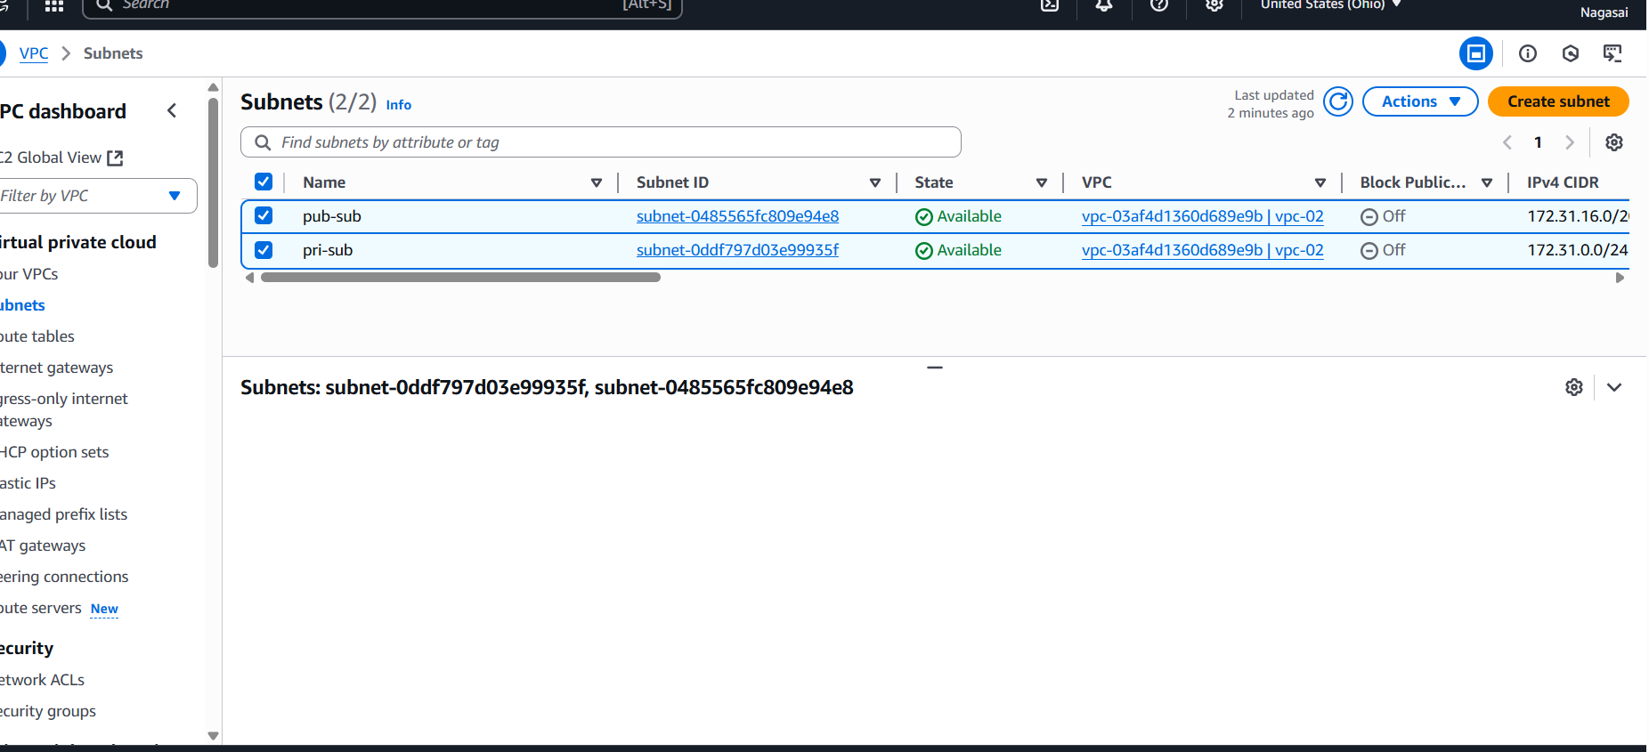

- Enable VPC peering for cross-region.
Go to vpc servicespeering connections click on create peering connections.
Attach vpc id and for cross region we select my account and another region.
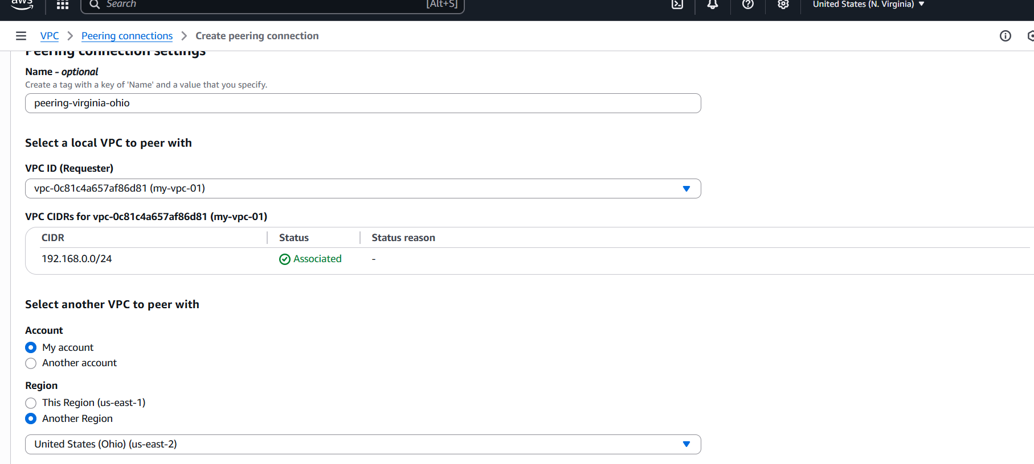
Click on peering connection.
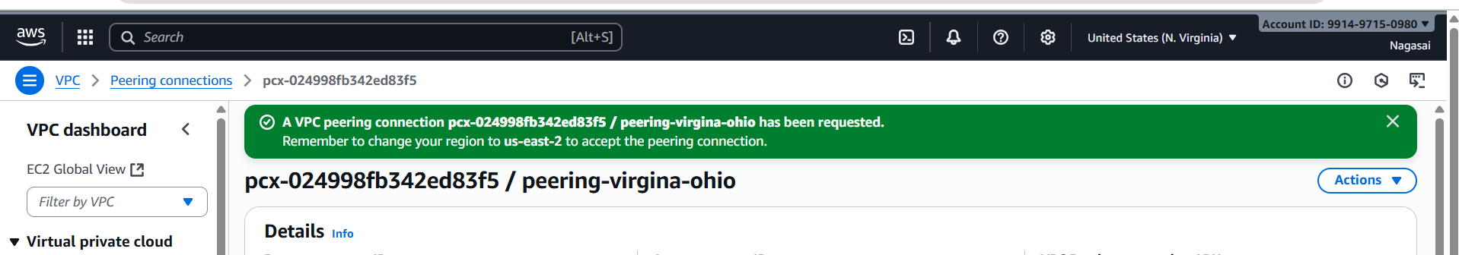
Once peering connection is created and accept the connection in other region.
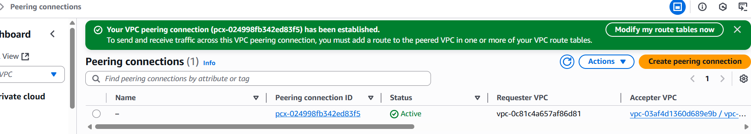
Also modify the route tables.
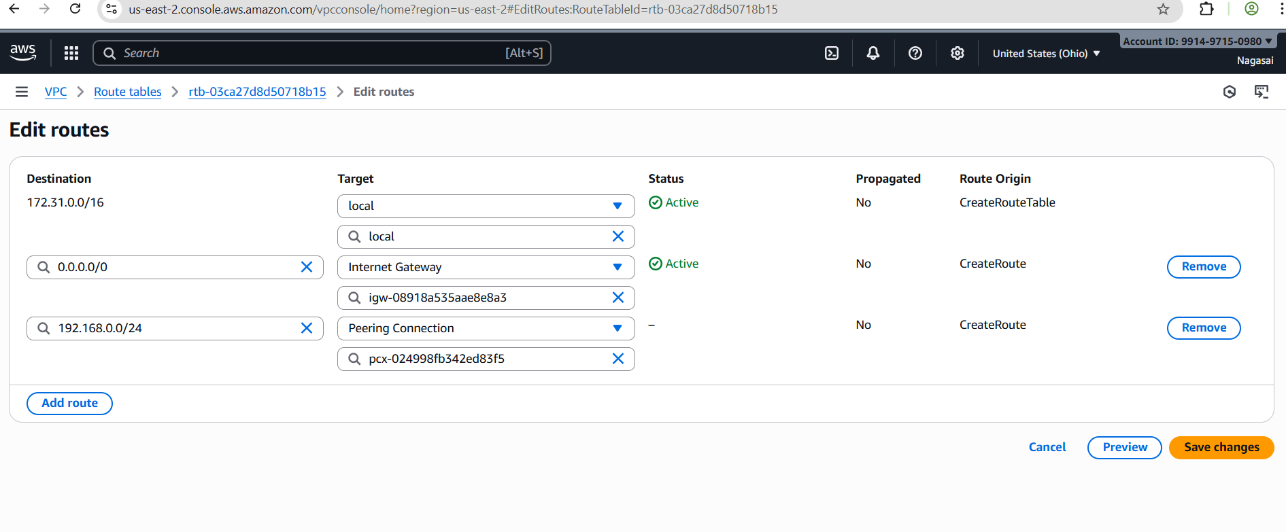
3. Enable VPC peering for cross-account (you can collaborate with your friend to do this task).
Go to vpc servicespeering connections click on create create peering connections
Attach vpc id and for cross account we select different account and another region.
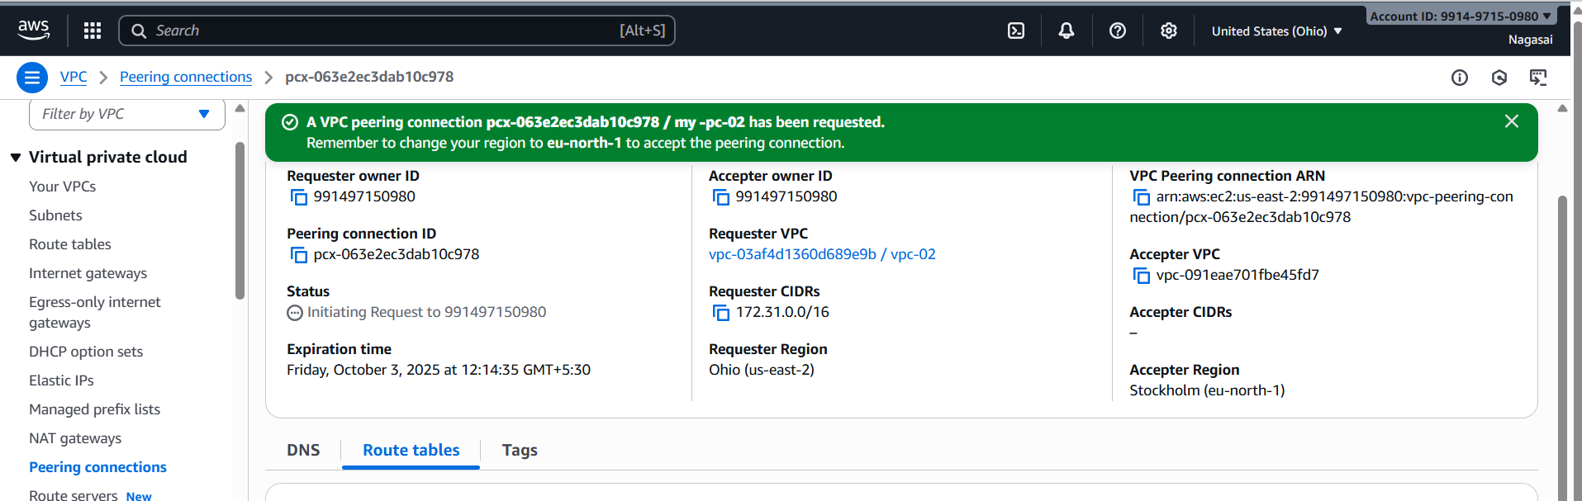
Once peering connection is establish and accept the request in another account.
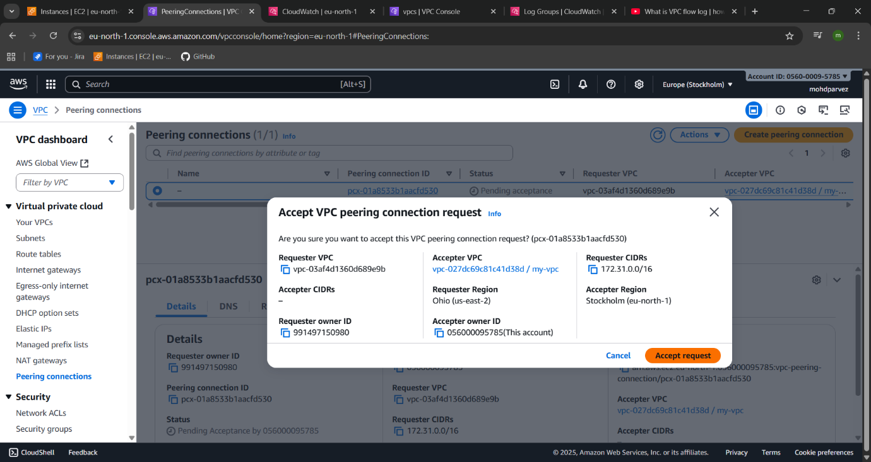
Once, peering connection is establish and also modify the route table.
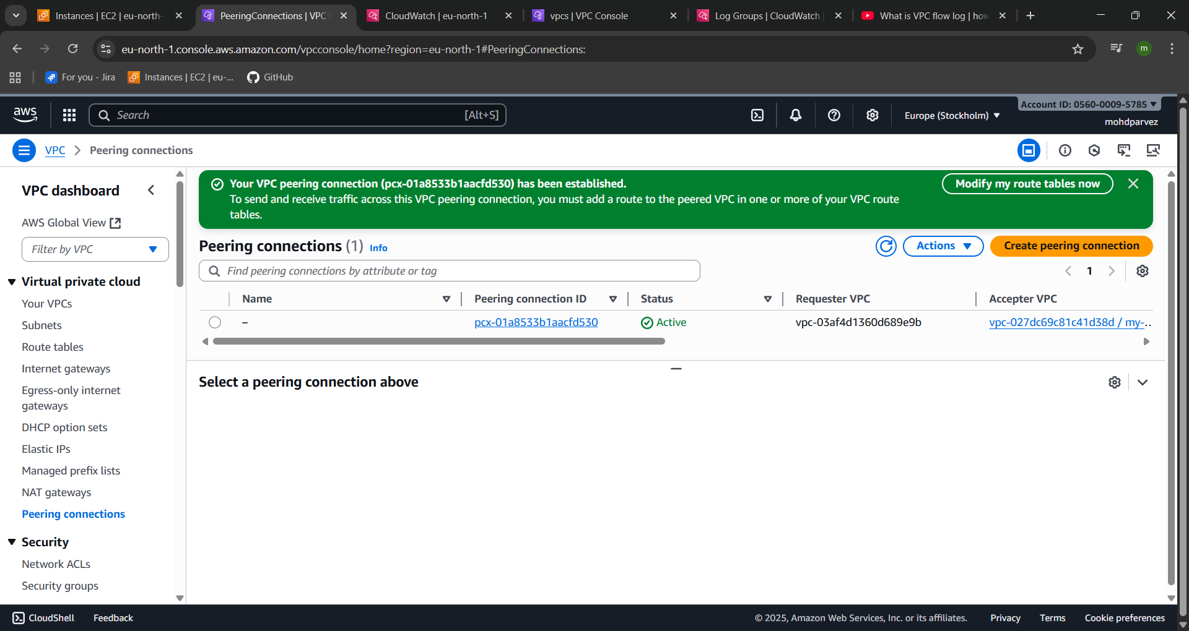
- Set up a VPC Transit Gateway.
For create transit gateway we create 4 vpc with 1 public subnet and 1 private subnet.
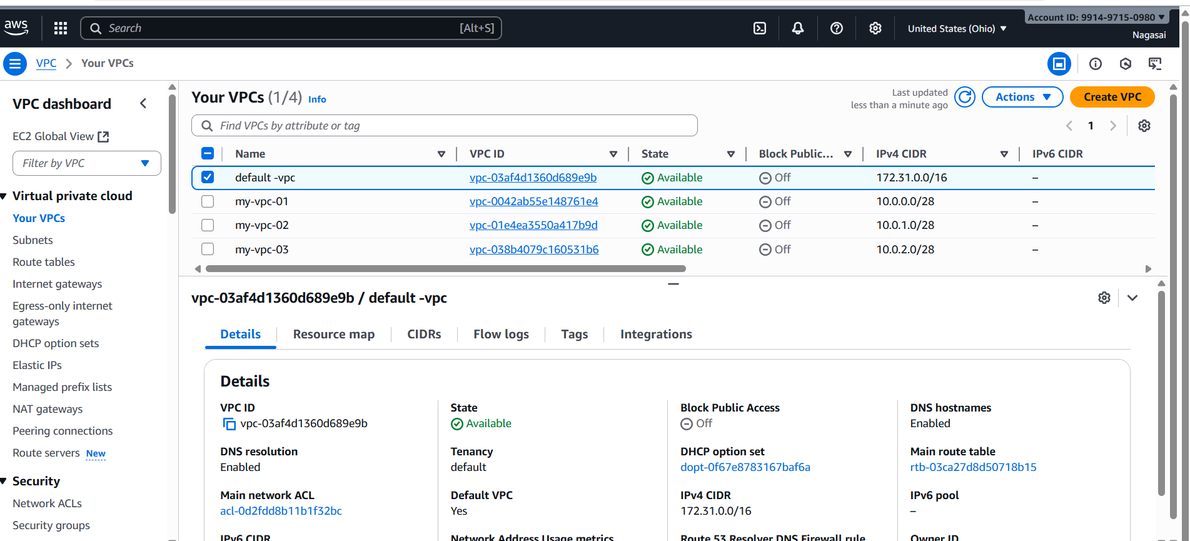
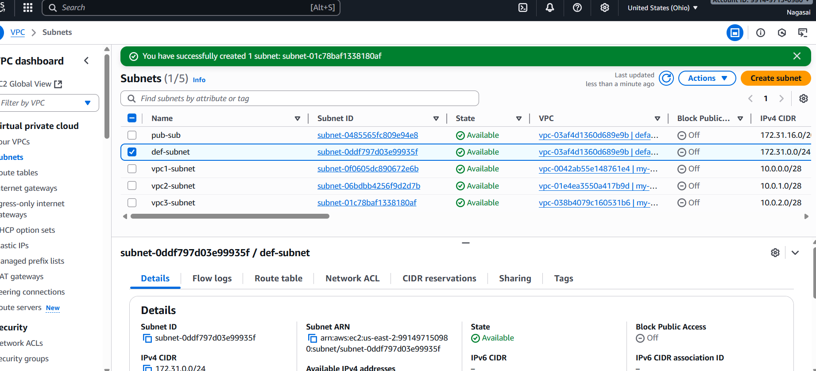
Now, create transit gateway.
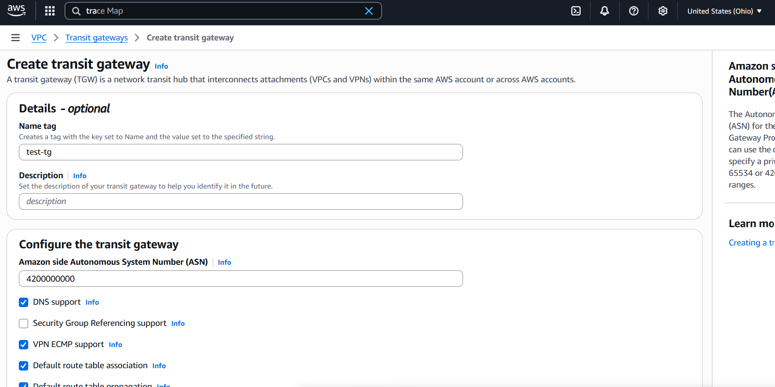
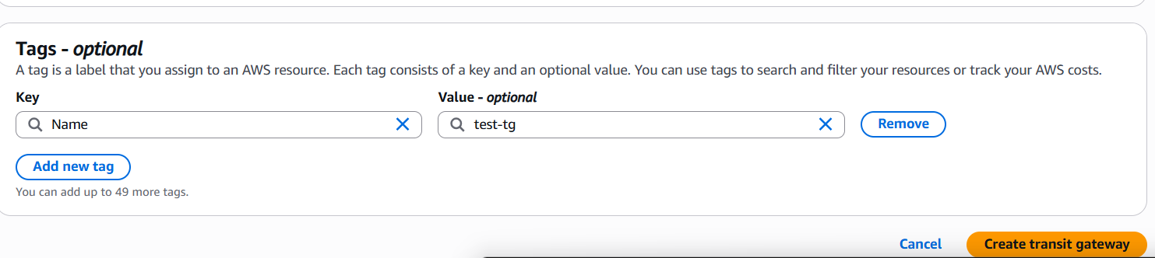
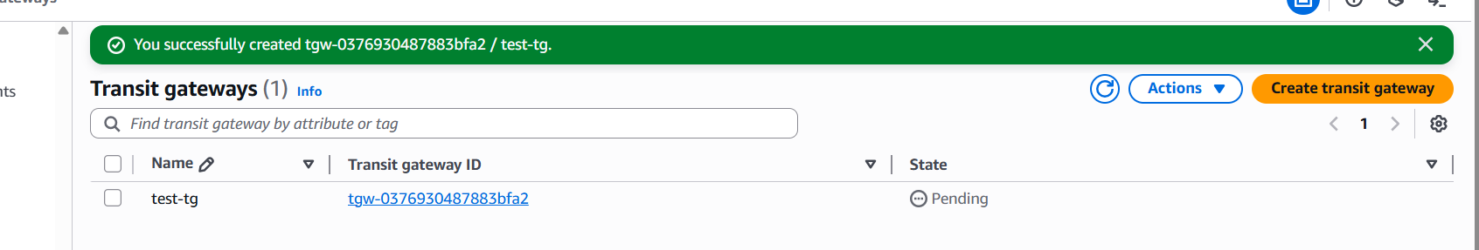
Now go to transit gateway attachments and create 4 attachments for 4 vpc.
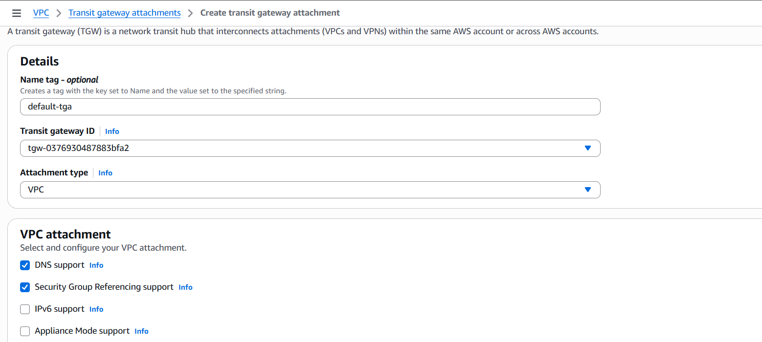
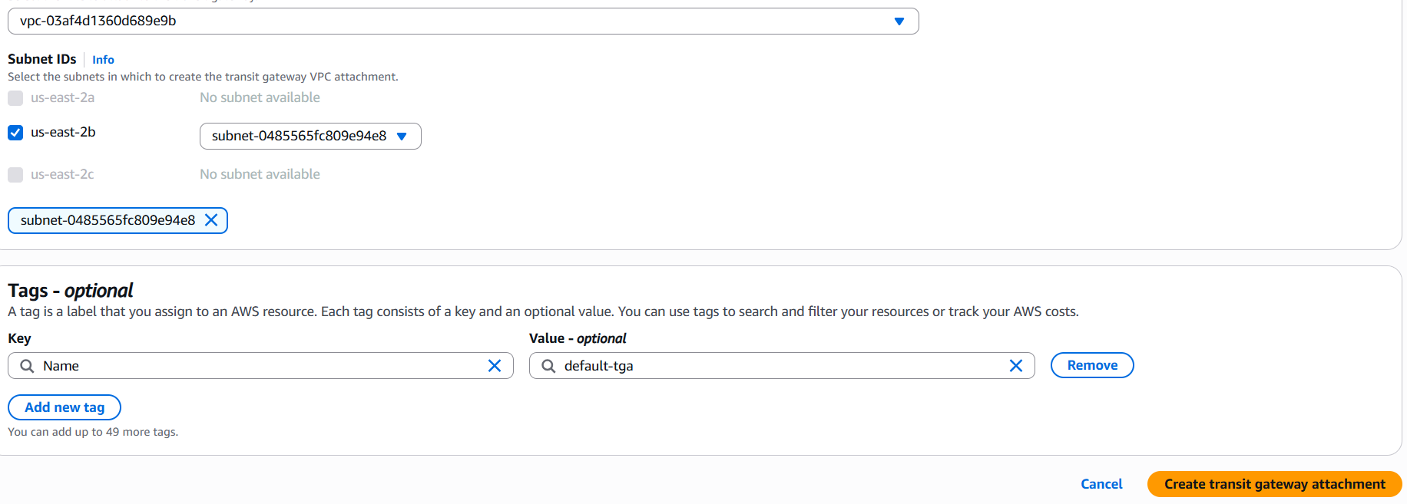
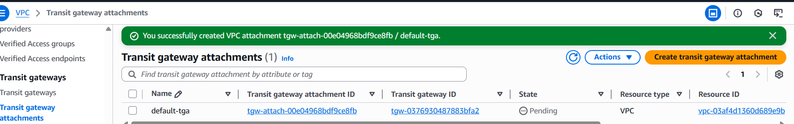
Similarly, we attached transit gateway attachments to remaining vpc’s.
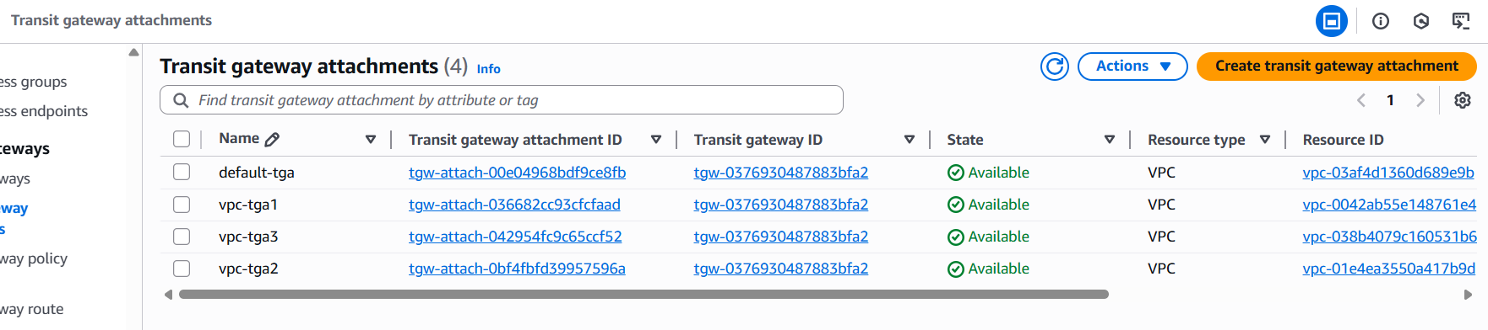
By default it will create transit gateway route tables.
Now, launch 4 ec2 instances in public subnets.
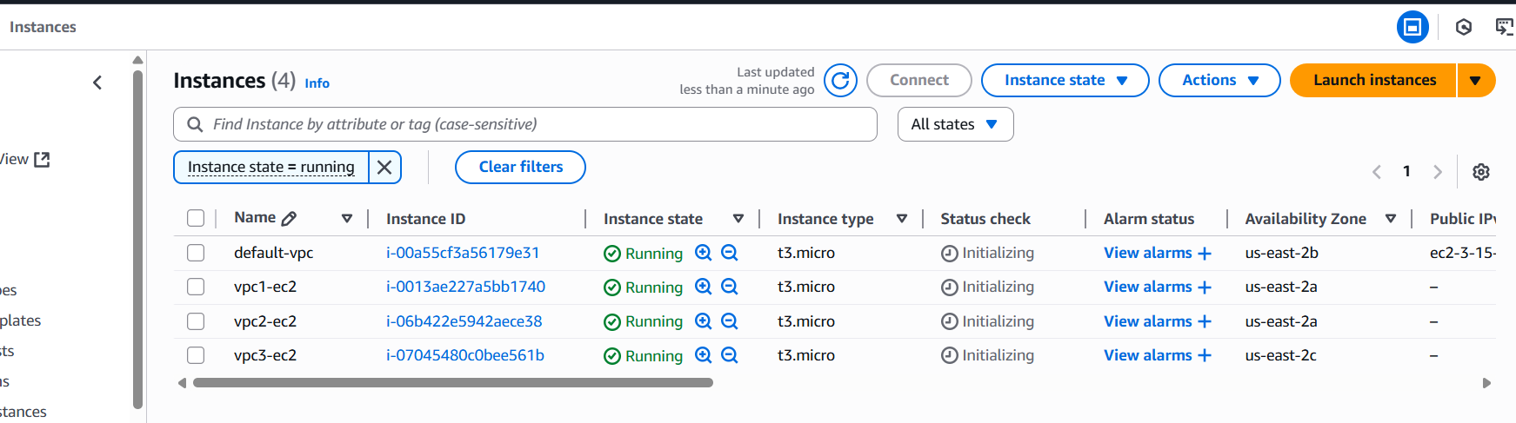
Now, go to routes of 4 vpc and add all the CIDR range in routes with transit gateway. And also add internet gateway.
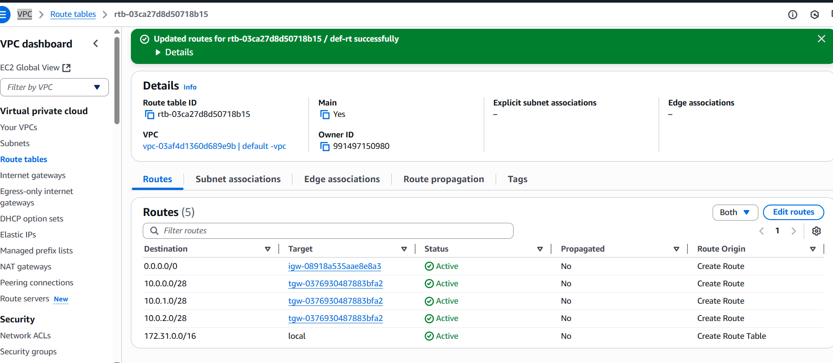
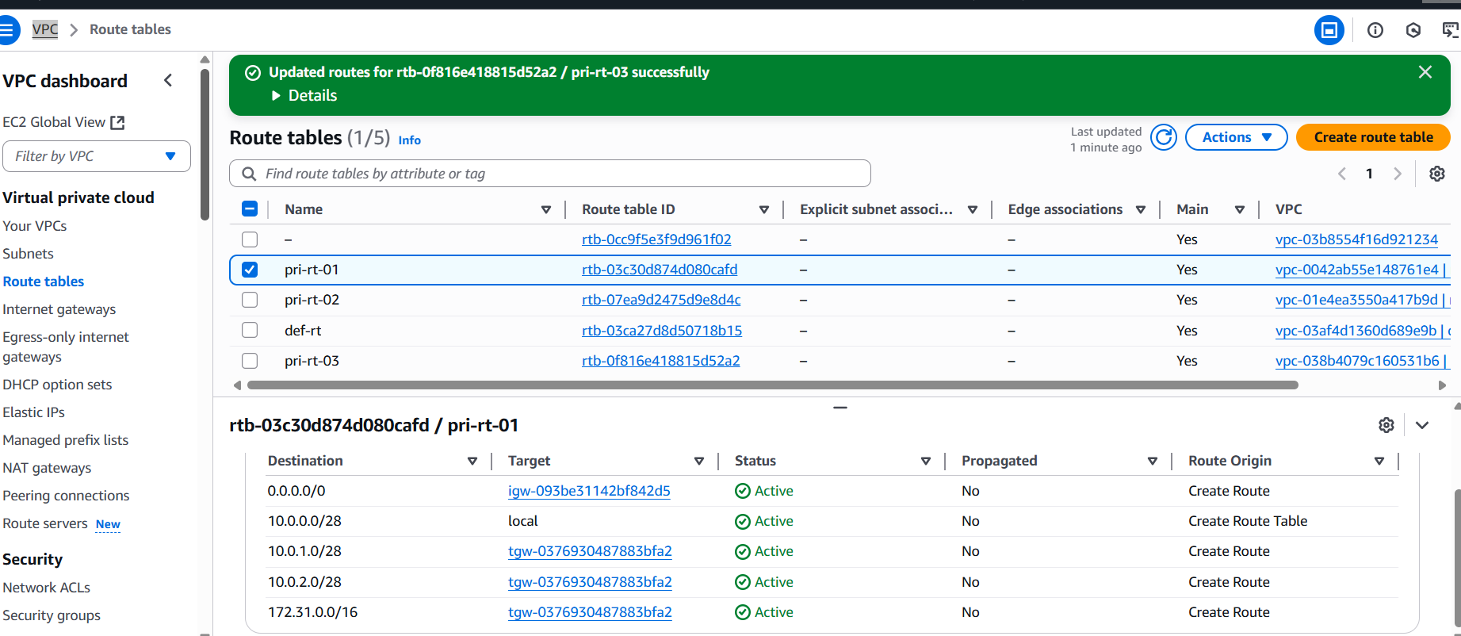
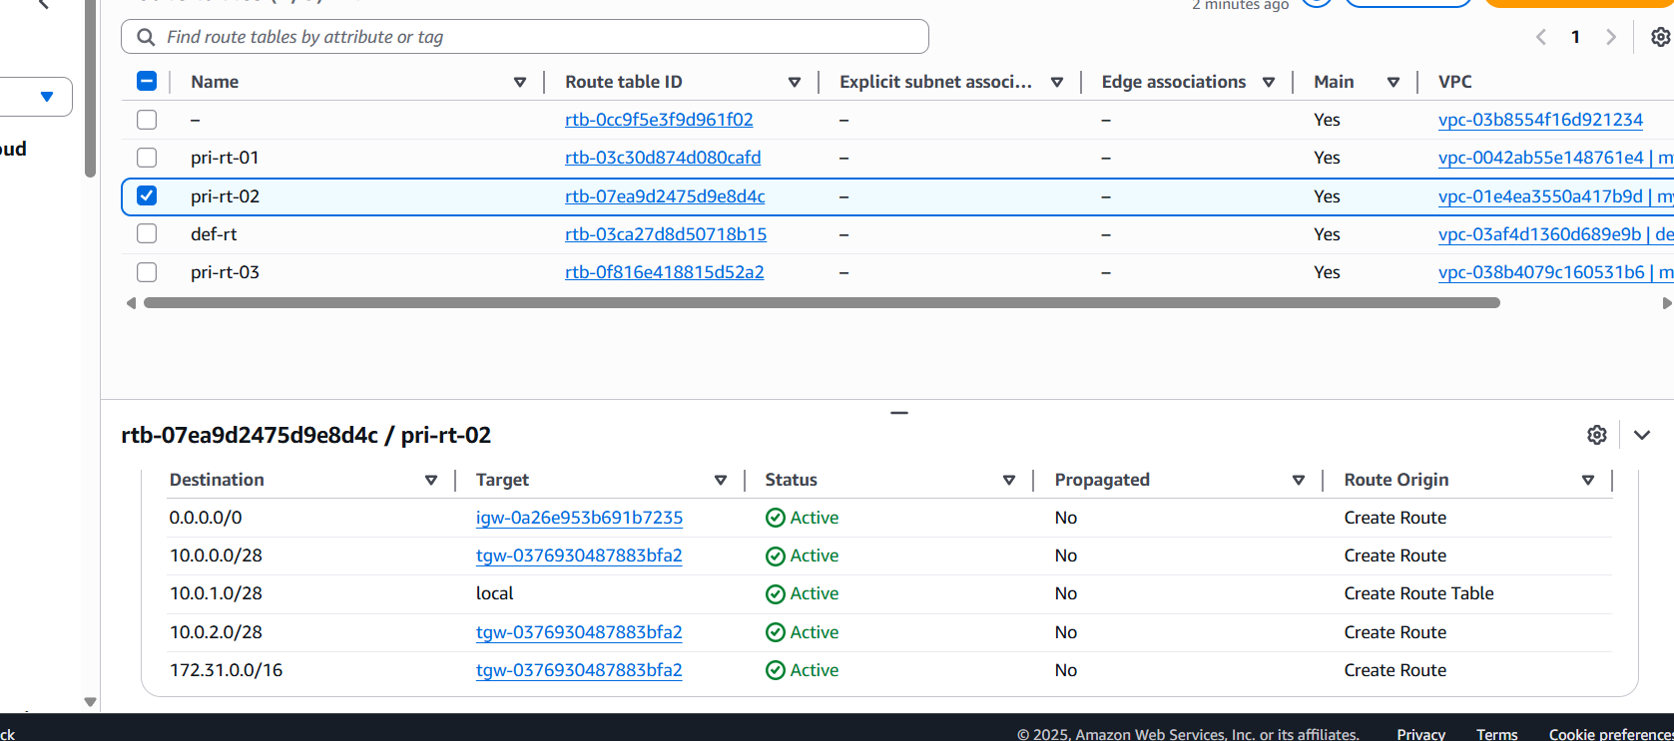
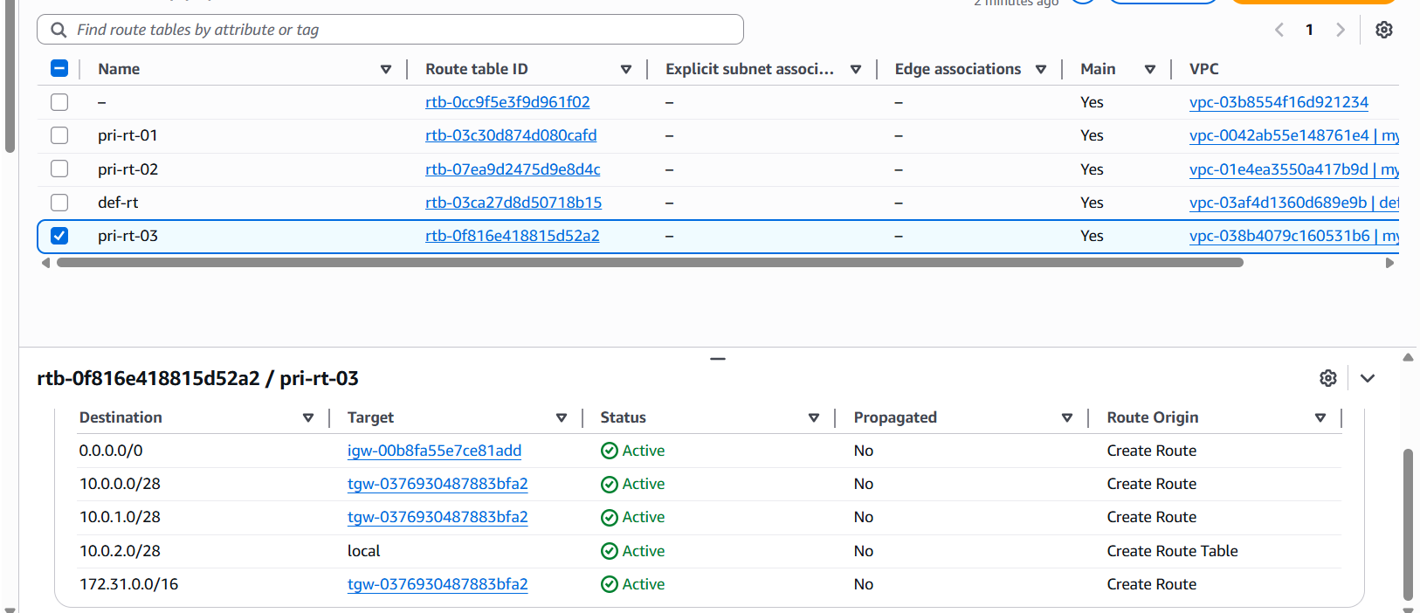
And also updated the security group with all traffic open.
Now connect to public ec2user and ping second private ip of ec2 instance using ping command.
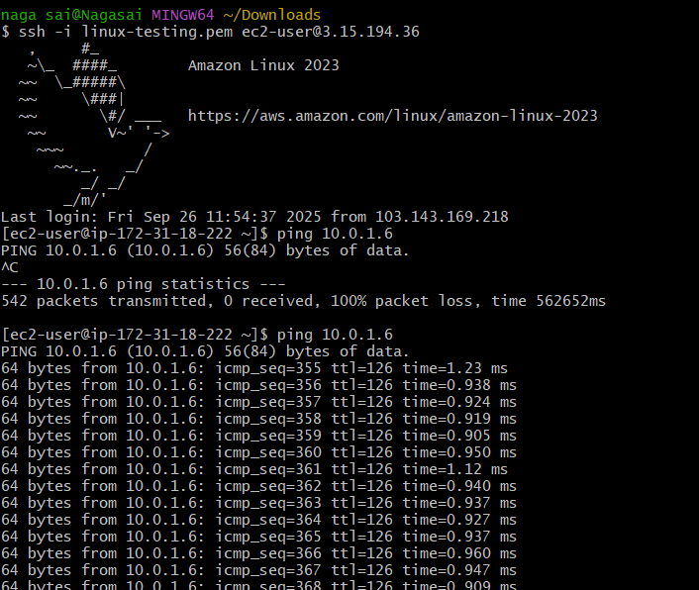
- Set up a VPC Endpoint.
Vpc end point is used to connect aws resources internally without internet connection.
For that, we have created one public subnet and one private subnet.


We can use public ec2 as bastion/ jump server and connect to private ec2 and execute aws s3 ls.
This will not work because of internet access.
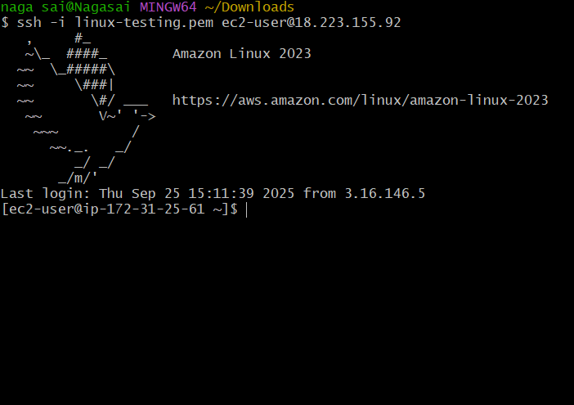
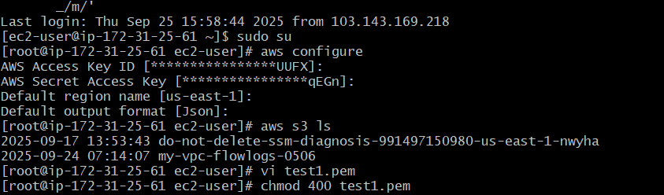
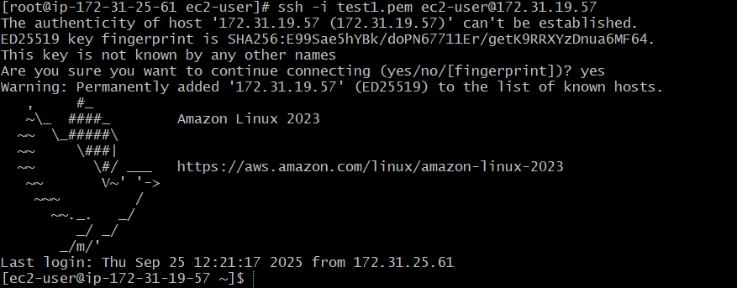
Now go to create end point service.
Go to vpc end pointscreate end point.
Select aws services and search for s3 and use s3 end point service.
In network settings attach vpc and select private route table and click on create end point.
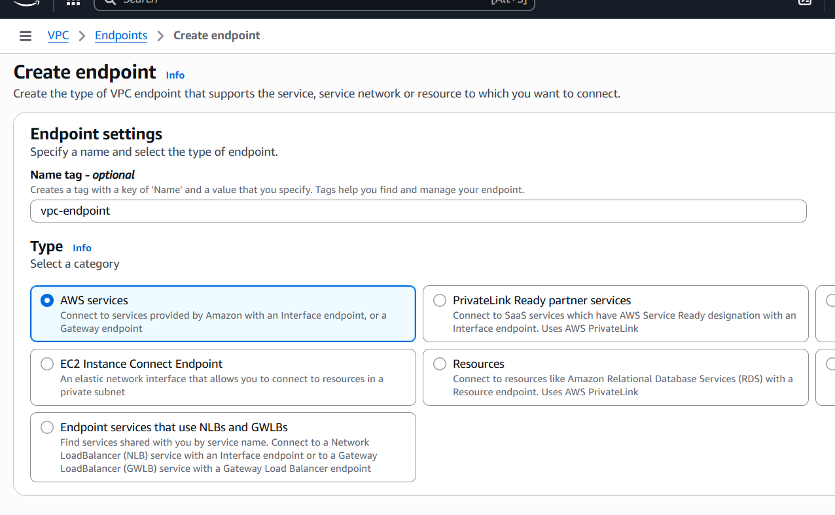
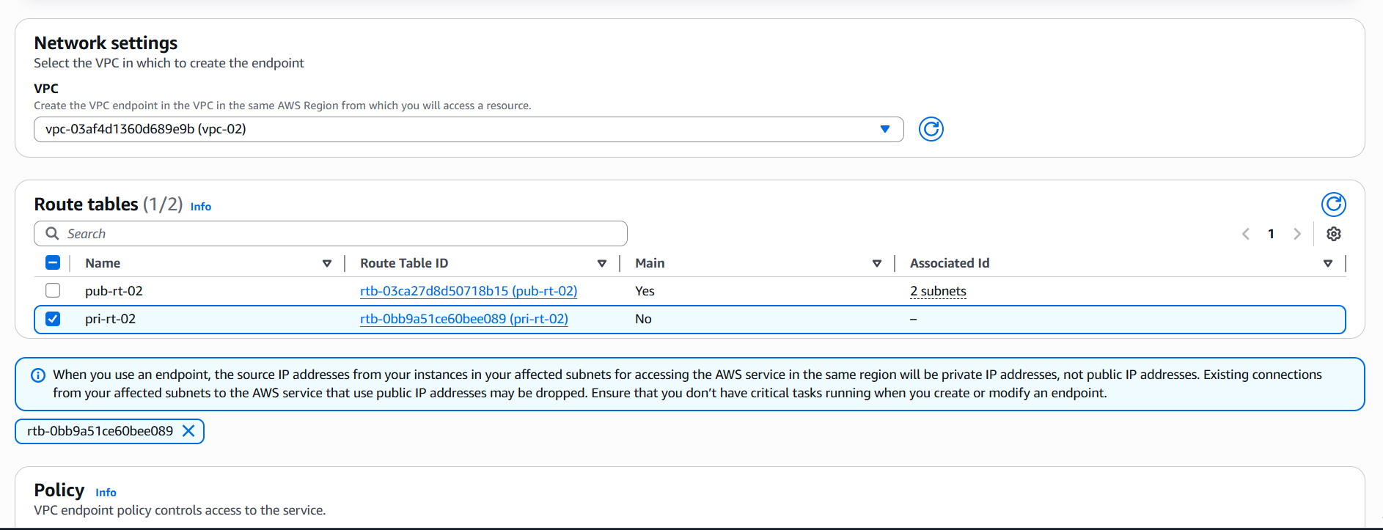
Now, successfully created end point service.
Also, updated the route table to particular end point and this endpoint is mapped with s3.
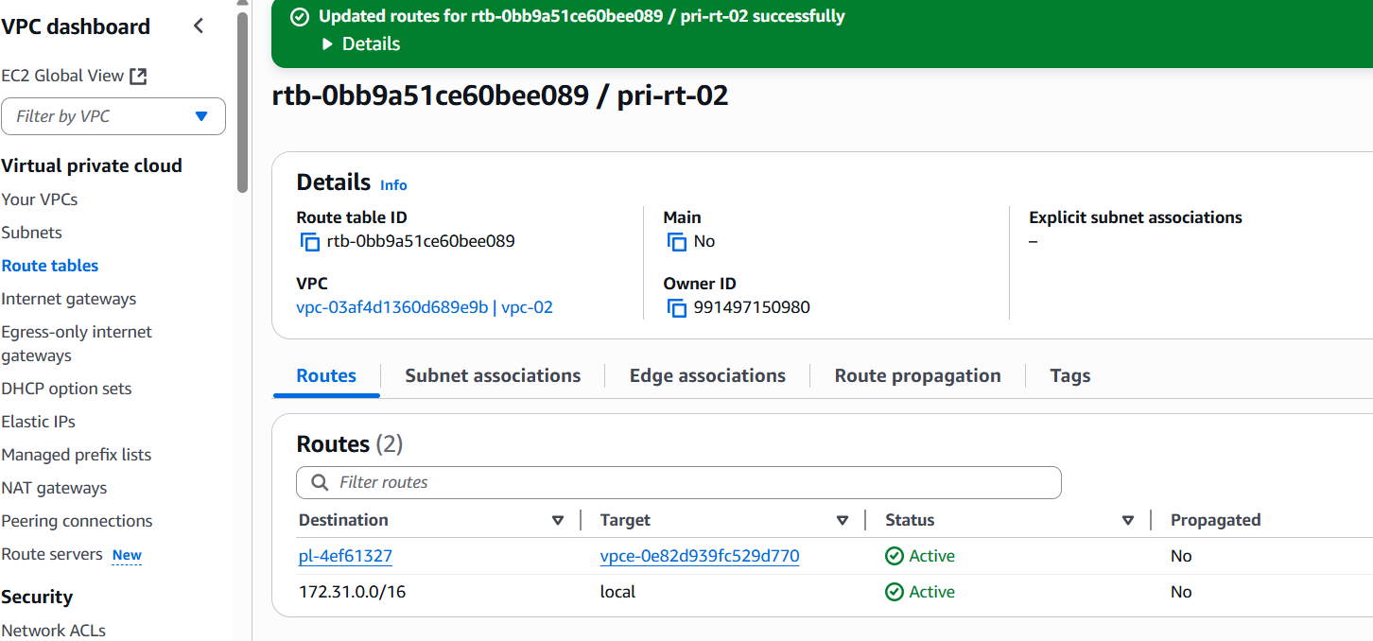
Now try to access s3 with private ec2 and this will work.
